Charlie Ansell – K00203841

4th year project proposal

Title

My idea for my 4th year final project is something that is now becoming more of a norm in the gaming industry, I am proposing to develop a data analytics library to assist in the development of a companion app for a video game.

Aims

The aims of my 4th year project is to track user stats while they play the game, these details will then be shown to the user through the mobile device, so they can continue to view their stats while they are playing the game and while they are not playing so they can keep a digital track of their game data wherever they are.

Once this is complete then developers will be able to use the data analytics library that I have developed in their game to be able to collect all the player behavioural data that they need and then be able to use that data to create their very own companion app for the players.

Also, throughout doing my project I aim to further improve my skills as a programmer by learning the new material that I will need to utilise in my 4th year project to be able to get it to work with the technologies that I have in it.

I will collect data from the game and send that data to a remote cloud database where this data will be housed for when I need to query it.

I aim to have a completed, reusable, library to collect player data and help developers create companion apps by allowing simplifying the collection of game metrics.

I aim to allow the user to compare their scores to others around the world, this will add competitiveness the game.

Finally, I aim to be able to gather that data back using a mobile application, the user will be able to see this data wherever they are in the world.

Objectives

The main objectives of my 4th year project will be to first get the data from the video game and get that data to be displayed to the user wherever they are, there will be a few ways in which I plan to do this.

To gather the data from the game I am going to create a library in C# to have different functions in it which allow data to be parsed into them and have some data returned so each function will return a different data set.

I will then need to get that data that is returned from the library stored in a cloud database so that any user will be able to access it from wherever they are, so to get the data stored I will have to use networking to get the data sent from Unity to the database.

Once the data is in the database I will need a means of getting that data back through the companion app and to get that data back then there will need to be some networking involved from the app side.

Once the user can see their individual data I will allow it, so the user can compare their score to other players in the app and see where they fall as a player among the leader boards.

Research

I have researched different articles online to see if I can find anything like what I am aiming to develop, I came across an article

https://unity3d.com/learn/tutorials/topics/analytics/introduction-unity-analytics

This is a video that talks about an introduction to unity’s own data analytics engine, the presenter goes on to talk about 2 main features that will be available to all developers. These features are a Realtime data view for developers and a heatmap for developers to see where players are dying the most in games or how many users are completing the levels. The Realtime data view is showing developers how many of their unity games are being downloaded, the revenue they are getting from that and many more. This may be good for developers but there is nothing for the player themselves to seem enticed enough to continue playing whatever game that they are gathering data on.

There are many different types of languages that can be used to develop the library that I will need to make if I want to gather data from a game, I have chosen to use C# because that is unity’s default programming language and will make more sense in creating a library in that language.

From researching online, I found this article:

<https://www.tristancartledge.com/setting-up-and-building-a-unity-class-library/>

this is an article that shows how to build a library for use within unity which is a great help because the article shows exactly what frameworks to target for the unity engine to recognise our compiled dll file to be able to call our functions.

I will be using android studio for the development environment for the mobile application because of the native android java language which I feel more proficient developing in and I have previous experience of the development environment and language.

  I will be using the scripting PHP for initiating the connections to the database as it is a powerful scripting language and unity and android studio both give access to networking libraries to make use of HTTP requests.

<https://docs.unity3d.com/Manual/UnityWebRequest-SendingForm.html>

This article shows us how to use www web requests within unity which utilises the unity networking library unity engine. Networking to allow unity to send http requests by using the www web request object which allows the user to post a form to a server which has parameters of the identifier followed by the variable that needs to be passed along too. This helps us to establish connections to databases through unity’s side.

Potential outcomes

Once this project is complete I can see it can be used in unity games to be able to help create companion apps based on the type of data it can retrieve about the player.

Users can compare their stats with the top players in the leader board and see how they rank among the best

The app can be used from anywhere in the world to see player data.

# 

**Project Plan**

# Project Hardware & Software Components

## 

## Supported Hardware Devices

The hardware devices that will be a part of my project will be a smartphone which will be essential to the core development of the project.

A pc will also be required to be able to program each individual components of the project.

## 

## Software components

This project will require many different pieces of software for it to be completed, these are:

**Android Studio** - for development of the application

**Visual studio** – for creation of the data analytics C# library

**Unity** – for implementation of the data analytics library and video game to be played

**Notepad ++** - To develop PHP code to transfer the data from the unity game to cloud database

# 

# Environment

## System Environment

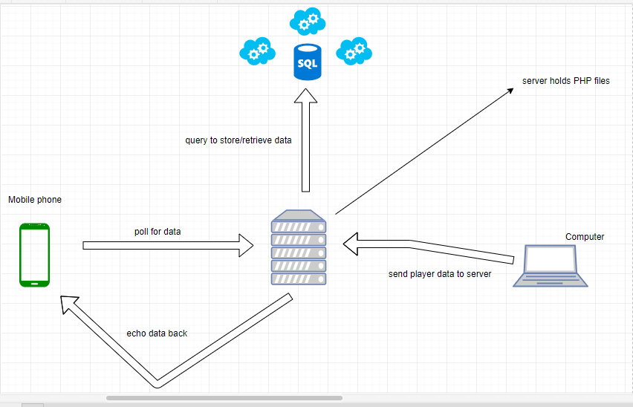

The system components of this project will be a computer to send player data to a server, a server to hold files that will send data to a cloud database, and a mobile phone that the user can use to view their stats

## Software Development Environment

The environments for the development of the software for this project will be in Visual studio which is going to be the C# language, notepad ++ which is going to be used for the PHP server scripting language, and Android studio which is going to use Java for the development language

# Development Strategies

The development strategy that I will be using to deliver this project will be the agile methodology view of project deliverance. I am selecting this methodology over others because the agile methodology says that features will be added as the project develops and new requirements are found along the way, which in agile development this is called sprints. This methodology I believe is best suited to my project because of the constant reflection that can be done on features and requirements, so functionality can be constantly added in sprints.

# Hardware/Software development schedule

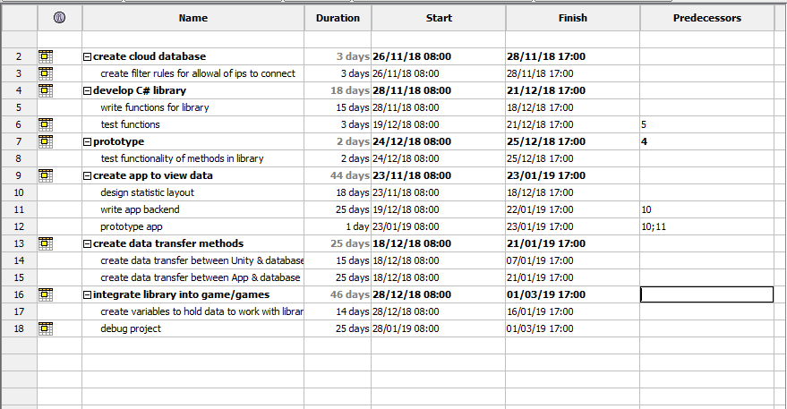

Figure 1 - project Gantt chart

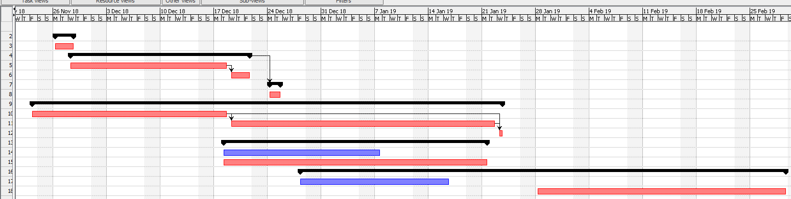

Figure 2 - Gantt timeline & dependencies

This is the schedule that I must follow through developing the project, this clearly shows me the tasks that I have ahead for me in the development of this project and shows me what I need to accomplish first before moving onto other tasks. For example, before I can prototype the library that I am going to implement I first need to create that library. If the main core features of the project, follow the critical path that is set then judging by this chart my project should be complete and be in testing and debugging mode by the 1st of March 2019 just in time for it to be uploaded.

# Hardware/Software Integration

There are issues relating to integrating the development languages with the software that I have chosen for this project and from what I have found so far, they are as follows:

* Integrating C# library from visual studio into unity
* Getting unity to connect to a cloud database which in turn connects to the App
* Choosing appropriate scripting language for connection of all components together

# Use case scenario estimates

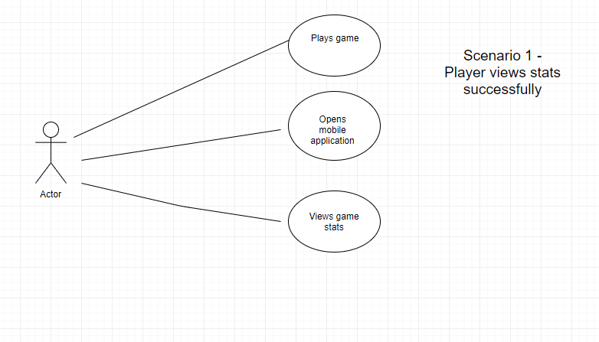

Figure 3 - successful use case

The first use case scenario that I can see is the successful outcome where the user/actor plays the unity game then once they have completed their play session then opens their companion app to be able to view the stats that they have gathered in the game. This will be the only successful outcome, with that being said it is really the only way that things can turn out with everything being successful with all aspects of the project.

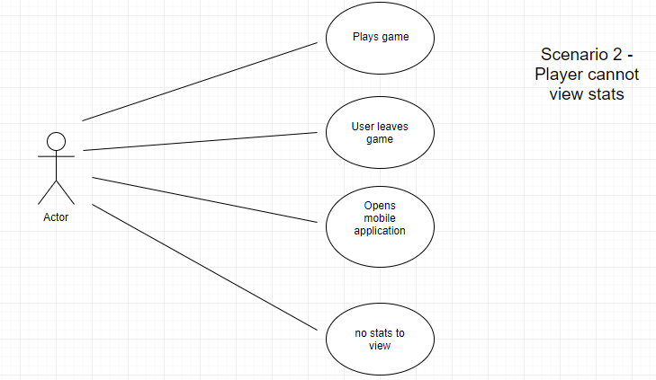

Figure 4 - unsuccessful use case

With this use case the user is unsuccessful in seeing any of their game stats because something interrupts their game and it unexpectedly ends before they finish the game. The user in this scenario begins to play the game and they leave the game before finishing it only to go onto the companion app mobile application to view their stats and because they had left the game before completion then they have no stats to view so the list on the mobile phone will be empty – this is not the ideal outcome.

# Risk assessment

|  |  |  |  |  |  |  |
| --- | --- | --- | --- | --- | --- | --- |
| Risk number | Hazards | What could be affected | How could it be affected | Initial risk rating | Control measures | Risk rating after controls |
| 1 | Database failures | App, PHP files | If database fails the app cannot gather data it needs, PHP files cannot access database | High | Choose an always online reliable DBMS, ensure extra time is spent maintaining availability. | Low |
| 2 | Erroneous values | App | Values the user sees will not accurately represent their gameplay due to values being skewed | medium | Ensure data gathering functions are properly tested and return correct results based on data entered | Low |
| 3 | Data transfer failure | App, database, PHP files | App, database and PHP files could be affected because the reason for data transfer failure could be the database itself | High | Ensure PHP code is debugged, and all bugs are eradicated, ensure a strong connection to the database. | Medium |
| 4 | crashing | All components | All components could crash due to bugs or glitches | High | Ensure code is clean, consistently debug. | Medium |

These are the risks that I can for-see with this project in its current state, much like with most of the components on this list they will change over time